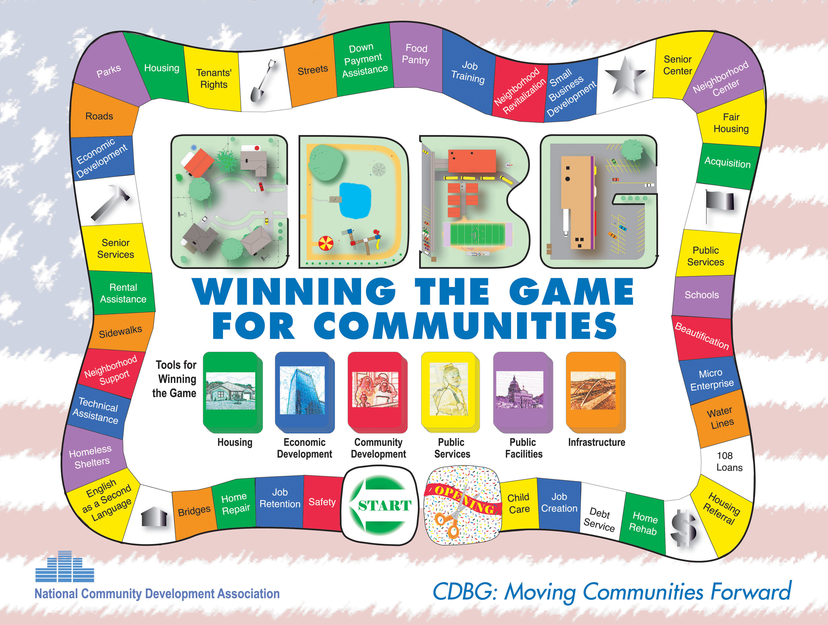

State of Maine
Community Development Block Grant Program
Property Management Guide


Office of Community Development
111 Sewall Street
59 State House Station
Augusta, ME 04333-0059
Phone: (207) 624-7484
TTY: 1-800-437-1220
www.meocd.org

PROPERTY MANAGEMENT

INTRODUCTION
Subsection 85.31 and 85.32 of 24 CFR Part 85 (The Common Rule) provides the basic standards by which local government property management procedures will be evaluated. This section contains key definitions and a series of procedures that set forth the steps grantees should take to assure compliance with federal regulations. CDBG grantees should implement these procedures to the extent that their own procedures do not fulfill the requirements described below.

The issues addressed in this section are principally germane to purchased property. Grantees should also consider the relative advantages of renting or leasing property, particularly when the expected life of the property extends beyond the term of the program.

The definitions, regulations, and procedures described below must be applied throughout the CDBG program.

TYPES OF PROPERTY
A community will typically purchase some property during the conduct of the CDBG program. This section discusses the various categories of property which may be purchased with CDBG funds.

Property is either real or personal. Real property means land, including land improvements, structures and appurtenances; it does not include movable machinery and equipment.

Personal property includes all property that is not real property. It may be tangible, such as desks, chairs, typewriters, lumber, tools, and drainage pipes, or intangible. Property having no physical existence is considered intangible. Patents, inventions, and copyrights are examples of intangible property.

Personal property is first classified as non-expendable or expendable. Non-expendable personal property is defined as all property other than land and improvements having a useful life of more than one year and an acquisition cost of $150 or more per unit, such as electric typewriters. The acquisition cost of purchased, non-expendable personal property is the net invoice unit price of the property plus the cost of modifications, attachments, accessories, or auxiliary apparatus necessary to make the property useful to the community development effort. Other costs such as installation, transportation, taxes, duty, or in-transit insurance shall be treated in accordance with your regular accounting practices.
Expendable personal property refers to all tangible personal property other than non-expendable. An example of expendable personal property is office supplies (e.g., paper, pens, etc.).

In addition to the categories of real and personal property, you should be familiar with the term "excess property". This category includes property under the control of a federal agency which has been designated as not necessary by the agency. This property can then be made available to other jurisdictions for valid public purposes. It may be real or personal property. An example of excess property is land taken over by CDBG from another agency and converted to a park.

Property Ownership
Federal and State regulations govern the ownership of property purchased in whole or in part with CDBG funds. This section discusses these regulations for real property and federally owned non-expendable personal property. You and other city officials, such as your legal counsel, should become familiar with these regulations.

Real Property
The title to real property which you acquire in whole or in part with CDBG funds shall vest with the city subject to the continuing use of the real property for the authorized purpose. If you determine that the real property is no longer needed for the authorized purpose, you may either keep the property for use in other community development projects approved by the State, or return the property to the State. If and when disposition of real property occurs, the proceeds should be treated as program income or miscellaneous local revenue, based on the following procedure on proceeds use. Use of the proceeds shall depend upon whether there is an active small cities grant at the time of disposition (proceeds are treated as program income) or no such grant is active (proceeds are treated as miscellaneous revenue).

Federally Owned Non-expendable Personal Property
If you acquire non-expendable tangible personal property with CDBG funds, title shall vest with your city subject to two primary sets of conditions that restrict your right to transfer title and the uses to which the property is put. These two conditions are addressed in the following two sections.

Right of the State of Maine to Transfer Title
The State of Maine may reserve the right to transfer title from your community to eligible federal agencies at the conclusion of the program. This may be done when the non-expendable personal property has a unit acquisition cost of $500 or more. If such a reservation is made, it shall be subject to the following standards:

- Property subject to the reservation shall have been identified in the grant or designated in a written communication from the State.

- The State agency must issue disposition instructions within 120 calendar days after the end of the federal support of the project for which the property was acquired. If the State fails to do so, you may continue to use the property in the program for which it was acquired as long as needed. When no longer needed for the original community development program, you may use the property in connection with your other federally sponsored activities in the following order of priority:

- activities sponsored by the State; and
- activities sponsored by other federal agencies.

When the property is no longer needed, it may be used for other activities in accordance with the following standards:

- You may use non-expendable property with an acquisition cost of less than $500 for other activities without reimbursement to the Federal Government or sell it on the open market.

- You may retain non-expendable personal property with a unit acquisition cost of $500 or more for other uses or sell the non-expendable personal property provided that your community receives approval from the State and compensation is made to the State. The amount of compensation shall be computed by applying the percentage of State CDBG participation in the cost of the original purchase to the current fair market value of the property.* For example, if the State CDBG participation was 50 percent in the program and the fair market value of the equipment at the time of disposition is $2,000, then your community must reimburse DECD $1,000. If you have no need for the property and yet it continues to be useful, then you should request disposition instructions from the State. The State will send each grantee a Disposition Policy for non-expendable property. Furthermore, the State retains the right to transfer property to another grantee after program closeout. The State shall give the grantee thirty days notice prior to the transfer of the property.

* Fair market value may be obtained by acquiring at least 3 estimates of the value of the item from vendors by use of an informal report. Verbal quotes documented. All values averaged to arrive at fair market value.

Allowable Uses
During the period that you hold the non-expendable personal property for use on the program for which it was acquired, you may make the property available to be used in other federal or State programs of the city as long as such sharing is reasonable and does not hinder the primary use of the property for community development. If use of the property for non-CDBG purposes exceeds 25%, a proportionate share of the cost of the property shall be derived from non-CDBG sources. Notification of such circumstances should be negotiated with the State.

Property Management Procedures
Federal and State regulations require that you maintain effective control over all property that you acquire in whole or in part with CDBG funds. In addition, you are required to assure that it is used solely for authorized purposes. This section discusses procedures that will help you comply with these requirements.

Property Register
The maintenance of a property register is an integral part of effective control over and accountability for all CDBG-acquired property. A sample property register follows this section. All categories of property may be recorded on a single register, though separate registers should be kept for each program if you administer more than one grant. When such property is purchased with CDBG funds, you should enter the applicable data on the register using the procedures described later in this section. You may wish to tailor the sample property register to provide additional information. For example, in the case of real property, you may want to record the previous owner of a purchased parcel of land.

Control
All purchased property must be adequately controlled and safeguarded. For example, real property, such as buildings, should be adequately equipped with security devices. Non-expendable property such as desks and typewriters should be reasonably protected from possible theft. Intangible property, such as a patent or a copyright should be adequately safeguarded by making sure that all appropriate legal filings have been completed.

Expendable property should be under the control of an authorized person who is responsible for receiving and issuing such materials. Certain expendable properties (e.g., lumber and drainage pipes) used in CDBG housing rehabilitation projects or street improvements should be controlled through a perpetual inventory system. This system should include:

- adequate records of the receipt of goods, issuance of goods and balance of items on hand;

- documentation of the person who authorized the issuance of goods;

- documentation of the location, such as a house or project, to which the goods were delivered; and

- documentation of the individual who received the goods.

Other expendable personal property such as office supplies do not need to be controlled through a perpetual inventory system. However, these items must be adequately safeguarded.

All purchased property of significant value, real or personal, should be covered by a reasonable insurance policy. Most grantees can fulfill this requirement by assuring said property is included on the town's blanket insurance policy.

You should meet with your finance director to obtain assistance in establishing a perpetual inventory system. The Property Register provides the basic framework for a perpetual inventory system.

Property Disposition Policy
Maine CDBG Program

Grantee:
Grant Yr:

The following items have been identified as non-expendable personal property purchased with CDBG funds as confirmed in your closeout dated_________. The left hand column identifies the number of the policy statement which relates to our interest in said property.

Policy % Interest
Statement # Property Identification to the State

(CHOOSE ONE:)
- Item's original unit acquisition cost was below $500. Grantee may use the property for other activities without reimbursement to the State Government or sell the property and retain the proceeds.

- Item's original unit acquisition cost was above $500. Property is to be transferred to the State as specified.

- Item's original unit acquisition cost was above $500. The grantee may retain the property for other uses provided that compensation is made to the original Federal agency or its successor. The amount of compensation shall be computed by applying the percentage of Federal participation in the cost of the original project or program to the current fair market value of the property. Reference CDBG Administrator’s Guide Financial Handbook for definition of fair market value.

- Item's original unit acquisition cost was above $500. Grantee is instructed to sell the property and reimburse the State (DECD) an amount computed by applying the sales proceeds to the percentage of CDBG participation in the cost of the original project or program. However, the grantee shall be permitted to deduct and retain from the CDBG share $l00 or ten percent of the proceeds, whichever is greater, for the grantee's selling and handling expenses.

- Other (specified below):

Failure of the State of Maine to issue this policy within 120 days after the end date of your contract results in the State's loss of disposition rights.

Please sign and return for our signature. A finalized copy will be forwarded to you.

______________________________ ______________________________
Nellie Goulette CD Grantee Authorized Signature
CDBG Financial Project Officer
State of Maine
Community Development Block Grant

Grantee Property Inventory Register

Location | Description of Property | Name | Model | Serial # | Cost | %Purchased wtht CDBG Funds | Date
Non-Expendable Personal Property: Do not include consumables.
Real Property: (In possession at time of closeout only.)

